**The Maths Corner**





**I know when** – knowing when and how to use the knowledge and strategies that they have learnt



‘*A moment of understanding does not guarantee long-term learning’* – children need to rehearse and apply the facts, practising methods and strategies that they have learnt – revising and consolidating their learning.

All classes will be holding maths information events in September, to show you the maths work that the children will be doing at school and let you know how you can help at home.

**I know how** – methods and strategies, such as addition and subtraction

**I know that** - the important facts that we teach the children, such as number bonds

Welcome to the first edition of our Woburn Lower School maths newsletter. Our aim is to help all children to develop essential lifelong maths skills alongside a positive attitude towards maths and we hope that we can help parents feel informed and confident to support us in this aim.

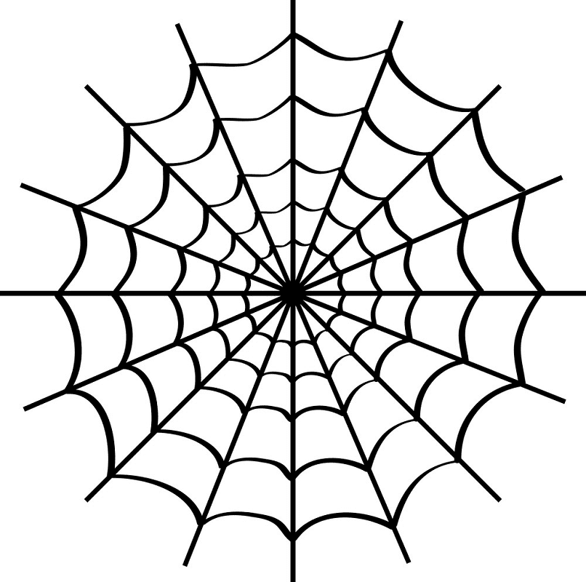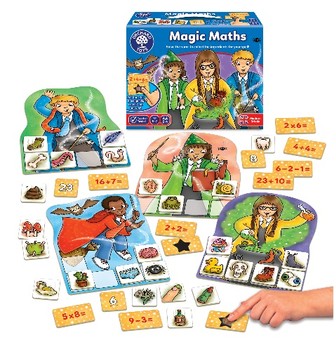

You can find information about what your child is learning this term in the topic webs that are on the class pages of the website. You can also find additional information about maths in the curriculum area.

The Maths Mum

Oxford Owl Maths

Please let us know if you have found any useful maths websites, books or games so that we can share the information with other parents.



Maths board games can help children practise a range of basic skills.

We aim to help children to understand the role that maths plays in our everyday lives and so we would like them to create an A4 poster at home showing a job in which maths is used – for example: a vet measuring out medicine for a pet, an architect drawing a design for a building … the more imaginative the better! Please send in your pictures by Friday 17th June. There will be a prize winner from each class.